Poseidon’s Steeds
Primary Objectives:
Students will:
- Be able to orally and/or through writing identify and describe each stage of the seahorse life cycle.
- Understand the unique aspects of seahorse physiology, life cycle, etc.
- Model their understanding of the concepts of buoyancy and be able to relate it to fish and swim bladders.
- Determine how the concepts of density, volume, and mass are related to fish buoyancy and how they are used in fish bladders.
- Understand why people create myths, be able to relate several myths of hippocampus from ancient times, and create a myth/legend of their own.
- Create at least one piece of original art related to seahorses.

Examples of Possible Academic Standards to Incorporate:
The following are samples of what kinds of standards you might choose with a Science focus in your lesson. Go to the spreadsheet or http://www.state.tn.us/education/ci/arts/index.shtml and choose the standards and vocabulary for each grade level that you are going to focus on. As with any lesson, part of your planning time will be spent making your own sample of the included projects so that you are aware of how much time and effort the projects will take as well as how you will want to modify them. During tutoring, parents and everyone in the home is to be involved in this lesson and make their own projects as well.

Science Academic Standards
Kindergarten:
- GLE 7.4.1 Observe how plants and animals change as they grow.
1st Grade:
- GLE 7.4.1 Observe and illustrate the life cycle of animals.
2nd Grade:
- 7.4.2 Sequence a collection of pictures or illustrations into the correct stages of an organism’s life cycle.
- GLE 7.4.1 Compare the life cycles of various organisms.
3rd Grade:
- GLE 7.5.1 Explore the relationship between an organism’s characteristics and its ability to survive in a particular environment.
- 7.12.2 Identify the force that causes objects to fall to the earth.
4th Grade:
- 7.4.2 Study the life cycles of a variety of organisms and determine whether these processes illustrate complete or incomplete metamorphosis.
5th Grade:
- GLE 7.5.1 Investigate physical characteristics associated with different groups of animals.
6th Grade:
- 7.2.1 Compare and contrast the different methods used by organisms to obtain nutrition in a biological community.
7th Grade:
- 7.4.1 Classify organisms according to whether they reproduce sexually or asexually.
8th Grade:
- GLE 7.5.1 Identify various criteria used to classify organisms into groups.
- 7.9.7 Apply an equation to determine the density of an object based on its mass and volume.
High School: Biology
- CLE 0.2.1 Investigate how the dynamic equilibrium of an ecological community is associated with interactions among its organisms.
- SPI 0.2.6 Predict how a specific environmental change may lead to the extinction of a particular species.
- SPI 0.2.4 Predict how various types of human activities affect the environment.
- 0.2.5 Conduct research on how human influences have changed an ecosystem and communicate findings through written or oral presentations.
High School: Physics
- 1.1.5 Investigate and apply Archimedes’s Principle.
- SPI.1.1.5 Evaluate and describe the phenomena related to Archimedes’ Principle
- 1.1.21 Determine the magnitude of the buoyant force exerted on a floating object or a submerged object (FB = mfg = ρfVfg).
- 1.1.22 Investigate the apparent weight of an object submerged in a fluid (Fnet = FB – Fg).
- 1.1.23 Explain, in terms of force and/or density, why some objects float and some objects sink.

Examples of Possible Academic Vocabulary to Incorporate:
The following are a very few samples of what kinds of vocabulary words from the K-12 Vocabulary Lists you might choose to incorporate naturally with your lesson.

Kindergarten:

- animal
- change
- collect
- color
- food
- growth

1st Grade:

- Adult
- Balance
- Classify
- Insect
- Life cycle

2nd Grade:

- habitat
- offspring
- organism
- parent
- similarities
- differences

3rd Grade:

- endangered
- force
- heredity
- physical change
- predator
- prey

4th Grade:

- behavioral adaptation
- camouflage
- migration
- mimicry
- metamorphosis (complete/incomplete)
- physical adaptation
- physical change
- reproduction

5th Grade:
- Inherited traits
- Gravity
- Symbiosis
6th Grade:

- Cause and effect
- Ocean current
- Scavengers
- Climate change
- Control
- Criteria
- Variable
- Protocol

7th Grade:
- Sexual reproduction
- Speed
- Tissue
- Phenomenon
8th Grade:
- physiological adaptation
- family
- species
- variation
High School:
- mutation
- natural selection
- innate/learned behavior
- Archimedes principal
- Buoyancy
- Buoyant force
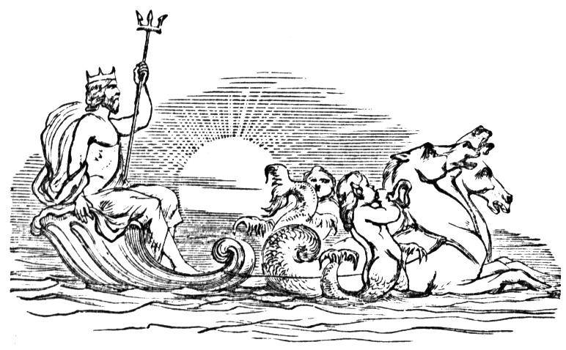
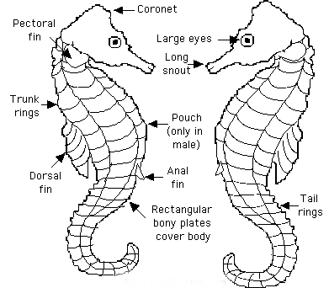
The sea horse is called Hippocampus, a Greek word meaning "horse monster." The strange and beautiful seahorse has fascinated people for centuries. It's not easy to be bizarre and endearing at the same time, but sea horses somehow manage to pull it off. Seahorses are amongst the most unusual of all fishes and probably the most "un-fishlike,” having look that is far from the familiar scaly creature caught on line and hook. Seahorses seem to be pieced together with many different parts and abilities of other animals. They have the head of a horse with the sucking snout of an aardvark, spines like a puffer fish, a pouch of a kangaroo, eyes like a lizard, the tail of a monkey, an armor plated body like the Stegosaurus dinosaur, the ability to change colors like a chameleon and the ability to wrap their tails around things as some monkeys can. With all of that these fascinating fishes are anything but ordinary. Bizarre, otherworldly, and yet somehow completely plausible.
Did You Know?
Seahorses have a crown on their head, called a coronet, which is unique to each individual seahorse, no two are the same, much like a human fingerprint.
Poseidon’s Steeds
A fish that looks like a horse, a dragon, and a plant? Amazing, and even better, true! They even have really cool names like including ribbon pipehorses, leafy and weedy sea dragons, alligator pipefish, and dwarf, yellow, potbelly and zebrasnout sea horses.
At one time confusion surrounded the seahorses. Seahorses were so puzzling that it took a while for them to be classified as fish. Even in the nineteenth century there was confusion and thoughts that they might be insects or shrimp. But like all fish, they have gills, and they have a swim bladder that controls their buoyancy.
Did You Know?
At the back of the seahorse’s head is a star-shaped bony crest known as the coronet. This coronet is unique to each individual seahorse, no two are the same, much like a human fingerprint.
Life cycle: A life cycle begins with the birth of a plant or animal and ends with that living thing growing older and producing more of the same kind of plant or animal before it dies. That is why it is a cycle, it goes in a circle. A seahorse is a fish and classified as such because of its fins and gills. A seahorse is not only unique in physical appearance but in its life cycle as well. In a seahorse’s life cycle, it’s the male who gives birth. Like many animals, a seahorse’s life cycle varies between individuals and species. But there are six general stages of development or steps that most seahorses pass through: adult, daily greeting, courtship, pregnancy, birth and a juvenile stage.
Adults
Seahorses are truly unique, and not just because of their unusual shape. Seahorses have a long, horse-like head and a curled tail. Unlike many fish, seahorses do not have scales. The scales have been replaced by rings of about 50 rectangular bony plates, encasing the body in a semi-rigid skeleton. Seahorses often appear as if they are wearing armor because their body is covered with rather a thin skin stretched over a series of bony rings and ridges. Each species has a distinct number of rings. Seahorses swim upright, another characteristic that is not shared by their closest fish relatives, which swim horizontally.
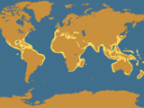
Another thing they don’t have is a caudal fin, which is the tail fin you see on other types of fish. This is why you typically find seahorses resting with their tails wrapped around coral and sea grass.
Seahorse Range
Seahorses come in all colors including orange, red, yellow, green and even gray, and can change colors, patterns, shape, and texture at will to improve their chances of survival! Unlike most other fish, many types of seahorses are monogamous (only have one mate at a time) and some even seem to mate for life.
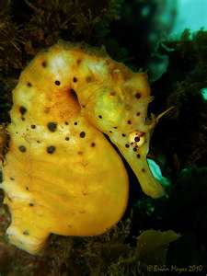
Seahorses make their homes in waters around the world Seahorses, including tiger tails, are most common in tropical seas, but they're found in all but the coldest ocean waters. Ocean water isn’t the same temperature all over the earth, just like air temperatures aren’t. Oceans near the equator, the tropical seas, are warmer than oceans at the top and bottom of the earth. The average temperature of the ocean surface waters is about 17 degrees Celsius (62.6 degrees Fahrenheit), the Arctic Ocean ranges from 28 degrees Fahrenheit to just above freezing in many places, but tropical oceans range between 60 and 80 degrees.
Creatures of the coastlines, they usually live in water no more than 50 feet deep. They're most often found in the IndoPacific and West Atlantic regions. These upright-swimming relatives of the pipefish can range in size from 0.6 inches (1.5 centimeters) to 14 inches (35 centimeters) long. No one knows how many seahorses actually exist. That’s because identifying seahorses is difficult. The smallest known species, discovered in 2008, is the half-inch-long Satomi’s pygmy seahorse; the largest species is the potbelly seahorse, which grows to about 14 inches long. They live in seaweed beds in warm water and are very very slow swimmers. A seahorse moves so slowly that it would take one about 5 minutes to cross a regular bathtub! Adult seahorses spend most of their lives within a small home range, or a territory that may vary from the size of a ping pong table to that of a football field. If seahorses are caught in rough water, they can actually die of exhaustion since are such weak swimmers.
Armored Fish?
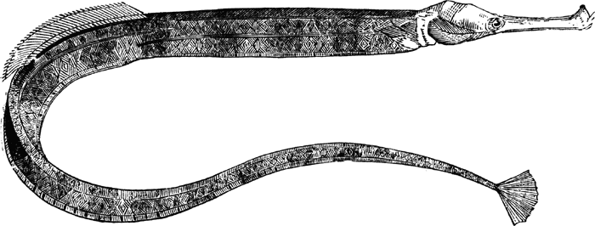
A protective bony armor cleverly protects seahorses from imminent danger. So strong is this armor that it is almost impossible to crush a dried dead seahorse in your hands. Its’ tough skeleton makes it unappetizing for predators, most fish don’t want to eat it, as it’s very bony and doesn’t have much meat, so seahorses are usually left alone. The female is totally enclosed in this protective armor, while the male is similarly enclosed except for the lower part of its abdomen. The armor surrounding its body often shows a number of bony rings. The armor is strong, but it also limits the seahorse’s flexibility. A seahorse has to swim with its body held upright and it can bend its head down or up, but not from side to side.
The seahorse is unique among fishes in that its head is set at right angles to its body, a 90 degree angle, instead of straight in line with the rest of its body.
How do fish keep from sinking to the bottom of water or floating to the top?
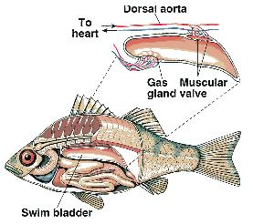
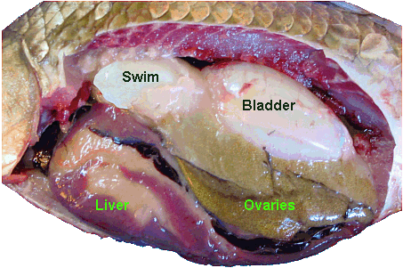
The seahorse uses its fins to swim vertically, and rises or sinks by cleverly altering the volume of gas within its swim bladder. In the ocean, fishes experience “push” and “pull” forces. They are pushed “up” by buoyancy and pulled “down” by gravity. So how does a fish manage to move up and down without having to swim all the time? It has a special body part called a swim bladder (also called a gas bladder) that helps out. An swim bladder is an organ or structure in both plants and animals that holds gasses and, in a fish, sits above the fish’s guts. (Ask the students why a plant might want an air bladder. Have they ever been to the ocean/beach and seen seaweed wash up on shore? Why would seaweed need air bladders? The bladders allow the seaweeds to float or stretch toward the sunlight above the water. By getting the plants' fronds closer to the surface, the air bladders also are assisting with photosynthesis (the process plants use to turn sunlight and oxygen into food) Fish rise and sink in the water the same way a helium-filled balloon or a hot air balloon rises and sinks in the air. Ask the students why it is an advantage for fish to be able to control rising and sinking without having to swim up or down (conserve energy). A swim bladder is very useful to a fish because it experiences two forces in water: gravity (which pulls it down) and buoyancy (which pushes it up). Fishes without swim bladders, like sharks, have to keep swimming so that they don’t sink! Explain to students that bony fishes have a swim bladder that helps fish do this. If this bladder is damaged, and it loses even a tiny bit of gas, the seahorse sinks to the bottom, thanks to gravity, where it will lie helpless until it dies.
Swim Bladder Images Credit: EarthLife. http://www.earthlife.net/fish/bladder.html. Accessed 9/21/11. All Rights Reserved.
Model Swim Bladder:
Inflate a long, skinny balloon as much as you can and then tie it to avoid letting the air escape. Tip: Use a white or cream-colored balloon for a more accurate air bladder model.
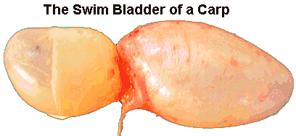
Tie a red string around part of the balloon, about one-quarter of the way in. Tie the string tightly so that the balloon is divided into two parts. The red string will represent the pneumatic duct that connects to the air bladder. Paint or draw veins on the longer side of the balloon to represent the veins inside a swim bladder. Use red paint or a red marker to draw the veins.
Buoyancy?
Everyone has experienced the fact that things feel lighter under water than they do out of water. This is due to a buoyant force upward. The buoyant force is equal to the weight of the liquid that the object displaces. To see how this works, you need to understand the various forces at work in the air and underwater. While these two different environments seem very different to us, water and air are actually very similar. Both are fluids, which are substances with mass but no shape. On Earth, an object immersed in a fluid (such as a fish in water or you and I in the air) experiences two major forces:
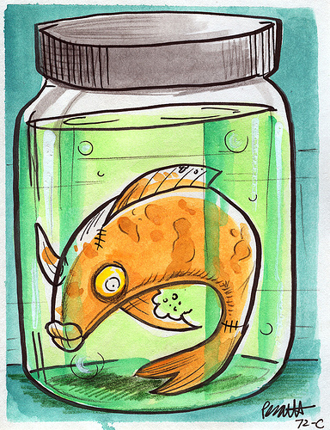
- The downward pull of gravity
Image Credit: Len Peralta. JawBoneRadio. http://www.flickr.com/photos/jawboneradio/583186526/. Accessed 9/21/11. All Rights Reserved.
- The upward push of buoyancy
Buoyancy is caused by a difference in fluid pressure at different levels in the fluid. Particles at the lower levels are pushed down by the weight of all the particles above them. The particles at the upper levels have less weight above them. Consequently, there is always greater pressure below an object than above it, so the fluid constantly pushes the object upward.
The force of buoyancy on an object is equal to the weight of the fluid displaced by that object. For example, if you submerge an empty gallon milk jug in a bathtub, it displaces (takes the place of, or the space of) a gallon of water. The water in the bathtub then pushes up on the jug with a little more than 8 pounds of force, the weight of a gallon of water, shoving it up. An object with greater volume is pushed up with greater force because it displaces more fluid. Of course, if the object is denser (and therefore heavier) than water, it doesn't matter how much water it displaces -- it will still sink.
Materials:
• mayonnaise or pickle jar (one quart or 32 oz.)
• tap water
• 2 glass marbles
• two balloons

1. Clean the jar out with soap and water. Let dry.
2. Have students fill the jar with 3 cups of water.
3. Stretch out the balloons and push a marble into the opening of each balloon.
4. Tie a knot as close as you can around one of the marbles. Have students predict what they think will happen, will the balloon rise or fall?
5. Have a student drop that balloon in the jar and see what happens. Were they correct in their predictions?
6. Blow air into the second balloon and tie a knot as close to the opening, or end of the balloon, as you can. Have students predict what they think will happen. Will the balloon rise or fall?
8. Drop that balloon in the jar and see what happens

- negatively buoyant – the downward force is greater than the buoyant force causing the object to sink.
- neutrally buoyant – the downward force is equal to the buoyant force causing the object to remain where placed in the water column.
- positively buoyant – the downward force is less than the buoyant force, causing the object to float.

Swim Bladder: An Under-the-Sea Ladder
The ability to control the pressure within the swim bladder is essential to fish. The buoyancy their swim bladder gives them allows them to remain at a certain depth in the water without effort. However because any given pressure of gas in their swim bladder is only neutrally buoyant (moving neither up or down, but staying in one place) for one specific depth if they change their depth they have to change the pressure in their swim bladder. The pressure exerted (put) by the water on a fish increases by one atmosphere (14.7 psi) for every ten meters of depth, this means that while the pressure a fish experiences is 1 atmosphere at the surface, it is doubled to 2 atmospheres just ten metres down, and doubled again to 4 atmospheres at 30 meters down. This increase in pressure compresses the gas in the fish's swim bladder so that at 10 meters the bladder is only half as big as it was at the surface! At 30 meters it is only one quarter as big. In order to maintain neutral buoyancy a fish must have twice as much gas in its swim bladder at ten meters depth as it has at the surface, and four times as much at 30 meters and so on.
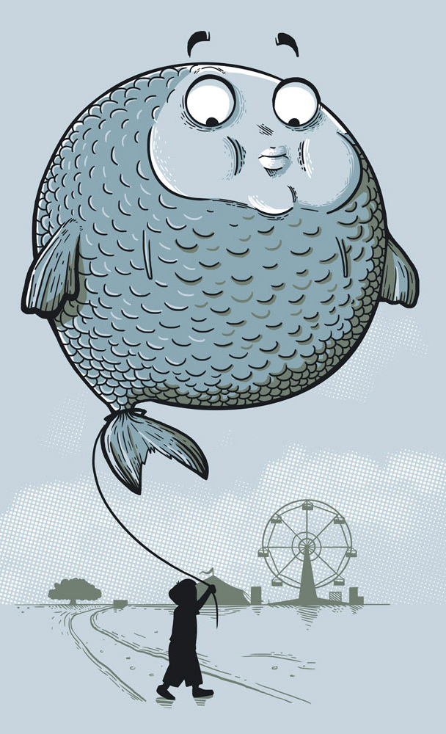
To rise up in the water, a fish must reduce its overall density (how compact it is) by increasing its volume (the amount of space it takes up) without significantly increasing its mass (how much it weighs.) In other words, it has to be bigger, but not heavier and to sink it has to be smaller, but heavier. Remember, most fish do this with their swim bladder. A swim bladder is just an expandable sac, like a human lung. To reduce its overall density, a fish fills the bladder with oxygen collected from the surrounding water via the gills (what helps fish breathe, by pulling the oxygen out of the water.) When the bladder is filled with this oxygen gas, the fish has a greater volume, but its weight is not greatly increased, since oxygen isn’t very heavy. When the bladder is expanded, the fish displace (moves or puts out of place) more water and so experiences a greater force of buoyancy. When the bladder is completely inflated (filled, rather like a balloon) the fish has maximum volume and is pushed all the way to the surface. When the bladder is completely deflated, all oxygen out, the fish has minimum volume and sinks to the ocean floor. To stay at a particular level, a fish fills its bladder to the point at which it displaces a volume of water that weighs what the fish weighs. In this case, the forces of buoyancy and gravity cancel each other out, and the fish stays at that level, it has neutral buoyancy. You may want to point out that cartilaginous fish (sharks and other fish who don’t have body structures with a lot of bones) do not have swim bladders and discuss why (they have a such a light skeleton they don’t need the help to conserve energy). Another type of fish that has no swim bladder are the highly energetic fishes, like the Tunny, they have oils in their body that help with buoyancy and they spend their whole lives actively swimming. For a fish that is always on the move and often changing depth quickly a swim bladder would be more of a obstacle than a blessing so they have simply learned to do without.

Buoyant Balloon Fish
This buoyancy activity allows students to experiment with different objects and observe which sink, which float, and how buoyancy can be altered without changing the mass of an object and help students answer questions such as the following.
- What makes objects float?
- How can boats be made of materials that are denser than water?
- What is the advantage of having a swim bladder?
Materials:
- 4 large balloons
- Small stones, marbles, or glass beads that will fit inside balloons (the glass beads used for flower arranging are often available at $1 stores)
- Graduated cylinder or measuring cup(optional-for measuring volume of fish)
Provide balloons of different buoyancy in a demonstration tank, or make enough for each pair of students to take them back to their own tank. Vary the air, water, and beads in the balloons to make sinkers, floaters, and balloons with no air that will sink if the beads are pushed together, but float if they are spread out and the balloon is placed flat on the surface.
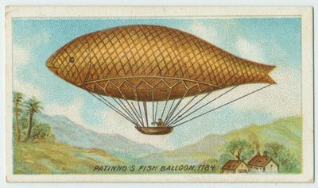
Then have students do the following explorations:
Image Credit: http://www.thevirtualdimemuseum.com/2009_05_01_archive.html. All Rights Reserved. Accessed 9/13/11.
1. Take a look at the various balloons in the tank. Feel free to handle them.
2. Can you make any of the sinkers float or floaters sink? If so, describe how.
3. Push two floaters to the bottom. Do they rise at the same rate? Why?
4. Pull two sinkers to the top. Do they sink at the same rate? Why?
5. Why do some balloons sink and some float? List some hypotheses.
6. Fill a balloon with a SMALL AMOUNT OF AIR, such that the balloon is about 1 foot in circumference (use a measuring tape). Once the balloon is the correct size, tie it off and one more time, confirm its circumference _________. [1 ft] Force the balloon underwater to the bottom of the water trough. Do not push it onto the bottom, but just hold it down. As one lab partner holds the balloon underwater, another should use the tape measure to determine the circumference of the balloon underwater. What was it? _______.[less than 1 ft] Was it smaller or larger than the circumference of the balloon when it was in the air? ___________. [smaller]
7. Experiment with your own balloons, adding or removing weights, air, and water to test your hypotheses.
8. Which of your hypotheses were supported?
9. How do your findings relate to the swim bladder in some fish?
10. What happens if you put oil in one balloon and an equal amount of water in another balloon? Fun Fact: Sharks use an oily liver to maintain neutral buoyancy, in contrast to fishes, which use a gas filled bladder. How might this phenomenon affect sharks, which have that big, oily liver?
11. When would a fish benefit by being a sinker?
12. When would a fish benefit by being a floater?
13. When would a fish benefit by having a neutral buoyancy?
Provide each student/group with materials. Have students create a "balloon fish" that has neutral buoyancy (does not rise or sink when placed in water). Have each group write down what they put in the balloon to achieve this, what they could use to make the fish rise, and what they would use to make the fish sink. Have each group share their information with the class.
Cartesian Divers
It's a classic science experiment using an eye-dropper, a soda bottle filled with water, and some great showmanship. Explore the science of Cartesian divers while amazing your students with your telekinetic powers. Yeah, right! Children can't help but ask, "How does that work?" Which provides a great opportunity for exploration and investigation.
FYI: This experiment is named after Ren Descartes (1596-1650), a French scientist and mathematician who used the diver to demonstrate gas laws and buoyancy.
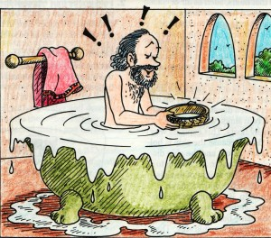
Materials
- A plastic soda bottle with a cap
- A glass eye-dropper*
- Water
- Tall glass
*Alternative: Use small plastic pipettes or eye droppers and hex nuts. Screw the hex nut onto the pipet up to the bulb. Cut off the pipet stem below the hex nut, creating a “Cartesian diver.”It will work just as well as an eye dropper.
- Place the Cartesian diver in a tall glass full of water. What does it do? Adjust the amount of water in the diver so it floats with its top just at the water line. (You can control how much the diver sinks or floats by squeezing the bulb to draw in or release water.) Why do the amounts of water and air in the diver cause it to sink or float?
- Fill the soft drink bottle with water to within 2 or 3 cm of the top.
- Place the eyedropper into the soda bottle. The eyedropper should float and the water in the bottle should be overflowing. (You can control how much the diver sinks or floats by squeezing the bulb to draw in or release water) Seal the bottle with the cap.
- Squeeze the sides of the bottle and notice how the eyedropper (called a diver) sinks. Release your squeeze and it floats back up to the top. Squeeze again and observe the water level in the eyedropper (it goes up!) For fun: Practice making the diver go up and down without making it look like you're squeezing the bottle. Amaze your students with your ability to make the eyedropper fish obey your commands!
Extensions: Have students try using a 3-inch x 3-inch piece of aluminum foil, try to make a Cartesian diver. Be creative. Describe what you did to make it dive. (If all else fails, wad it up and try.) Try different shapes and sizes of plastic bottles, such as dishwashing detergent bottles. How do they behave differently?
Extension: A Ketchup Fish?
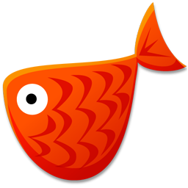
Is a diver the only thing that will show buoyancy? Cause a packet of ketchup to rise and fall on command in a bottle of water. People will think that you have the ability to move objects with your mind! Telekinesis? No, just cool science!

Materials
- Clear plastic soda bottle with cap (1-liter size works great)
- Ketchup packets
- Bowl
- Water
- First, you'll need to perform a "float or sink" test to see how the ketchup packet works. Fill a bowl with water and drop the packet into it. If it floats, great! If it sinks to the bottom, no sweat. This shows that atmospheric pressure in the packet is pressing hard enough on the air bubble inside the packet to sink it. If this happens, you get to make more trips to your favorite fast-food restaurant to find a ketchup packet that just barely floats!
- Scrunch the packet in half lengthwise and carefully push it into the soda bottle. Do not open the packet. Just carefully push it into the bottle without tearing the edges.
- Fill the bottle full to the brim with water and screw on the cap.
- Squeeze the sides of the bottle and hold the squeeze to make the packet sink. Let go and the packet rises. The packet of ketchup has learned to dive!

Why do they do that and How does it work?
The Greek philosopher Archimedes was the first person to notice that the upward force that water exerts on an object, whether the object is floating (a boat) or submerged (a fish), is equal to the weight of the volume of water that the object displaces. What that means is that the buoyant force is equal to the weight of the displaced water, displace more weight, it’s more buoyant, displace less weight, it sinks!
As you squeeze the bottle, you increase the pressure everywhere in the bottle. The higher pressure forces more water into the eyedropper, squeezing and compressing the air that’s in the eyedropper. This causes the dropper to displace less water, thus decreasing its buoyancy and causing it to sink. When you release the sides of the bottle, the pressure decreases, and the air inside the bulb expands once again increasing the displacement, thus the dropper's buoyancy also increases, and the diver rises. If you look carefully, as you squeeze, you can see the level of water changing in the dropper as you vary the pressure on the bottle.
As for the ketchup (fish):
The packet floats because an air bubble gets trapped inside the packet when it's sealed at the factory. If the packet sinks when you test-float it, then the air bubble is too small to make it float.
As you squeeze the bottle and push the water against the floating packet, you compress the air bubble into a smaller space. This happens because gases are more "squishable" than liquids, so the air compresses before the water. According to the density equation (Density = Mass divided by Volume), when you decrease the volume or make the bubble of air smaller, you increase the density and the ketchup packet sinks. When you release the pressure on the bottle, the compressed air expands inside the packet (increasing the volume), the density decreases, and the diving ketchup floats to the top of the bottle.
Notes on Extensions: If you try this using a thin, flat bottle, like a bottle dishwashing liquid or shampoo bottle squeezing on the wide sides of the bottle will increase the pressure inside the bottle, but squeezing on the narrow sides will make the volume of the bottle expand and the pressure inside to decrease. If you use such a bottle, adjust the weight or water content of a Cartesian diver so that it just barely floats at the top of the water. When this diver reaches the bottom of the bottle, it will stay there, even when you stop squeezing on the wide sides. You must squeeze the narrow sides to drive the diver to the surface. It will then stay at the surface even when the squeezing stops.
The key to this behavior is to carefully adjust the diver initially, so that it barely floats. As the diver sinks, the pressure outside the diver increases slightly with the water's depth. This increase is in addition to the increase in pressure you cause by squeezing the bottle. When the diver reaches the bottom and you stop squeezing, the pressure resulting from the increase in depth remains and continues to compress the air bubble a little. If the diver has been carefully balanced, this small compression of the bubble will be enough to keep the diver submerged. The process reverses when you squeeze the narrow sides to raise the diver.
For fun, have students decorate the top of the eyedropper to look like a seahorse and decorate the bottle using their imagination and creativity!
It’s Always Time for Dinner!
Because of their body shape, seahorses aren’t really very good swimmers and can easily die of exhaustion when caught in storm-roiled seas. They move themselves by using a small fin on their back that flutters up to 35 times per second. Even smaller pectoral fins located near the back of the head are used for steering.
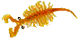
So instead of swimming all the time seahorses anchor (hook) themselves onto things with their prehensile tails. Prehensile means that it can be used like we use our hands to grasp and hold onto things by curling their tails forward (seahorses are unable to curl their tail backwards) while clinging to sea grasses and corals. Seahorses are related to pipefish, but unlike most pipefish, which are long and straight, not curled, and swim towards their prey seahorses have sit and wait for their victims to pass by. If they tried to swim after food, they’d never catch it. But with excellent camouflage and a lot of patience they catch a lot of food. Greedy and insatiable eaters, they eat continually and even the young ones can consume 3,000 or more brine shrimp per day, adults even more. They have to! Seahorses have no teeth and no stomach. Food passes through their digestive systems so quickly, they must eat almost constantly to stay alive. Of course brine shrimp aren’t very big, they only grow to approximately 1 cm, but that’s still a lot of tiny shrimp. [The one pictured is an adult brine shrimp. At approximately 2x its normal size]
Seahorses eat by a quite special snatch-sucking movement of their snout, striking at them with their snouts, creating a vacuum and sucking them into their snouts. This suction movement is so strong that a pretty loud noise is made. If something tasty passes above, they rotate their heads upward to bring their mouth close to the prey, the creatures' curved bodies mean that when they do this, their mouths also moved forward, helping to bring passing small crustaceans (crabs, shrimp, etc) within sucking distance of their snouts. All of them have fused jaws, meaning they can’t separate their jaws or open their mouths wide, so they have to suck up their food like we do through a straw.
Camouflage helps keep seahorses safe from harm because seahorses can match their color to the places where they live. That makes it hard for potential predators to see them.
The inability to move its head from side to side would in other creatures create problems, but the seahorse’s eyes can move independently, swiveling about to watch each side, which mean one eye looks left while the other eye looks right. Both eyes do not look ahead like our eyes do. The eyes can swivel independently, to look at two different things, or join together to make binocular vision, like we have. This unique ability allows the seahorse to look for enemies with one eye while searching for food with the other eye. It is also believed that with this binocular vision seahorses have, they can see their microscopic (so tiny we can’t see it without a microscope’s help) prey.
The following poem verses included with each section are from the Monterey Bay Aquarium PDF “A Seahorse Life Cycle: Father Knows Best!” www.montereybayaquarium.org/PDF.../Seahorse_Life_Cycles.pdf ©2009, Monterey Bay Aquarium Foundation. All rights reserved. Accessed 9/26/11.

“Seahorse lives alone in his home
And doesn’t like much to roam.
With his monkey-like tail
Seahorse holds on without fail
To make sure he won’t stray too far from home.
Seahorse spends lots of time every day
Waiting patiently for tiny critters to float his way.
With a SUCK and a SLURP
His straw-like mouth does the work
To swallow thousands of critters each day!”

Daily Greeting
An adult female seahorse chooses a male to be her breeding partner, or mate. Though they spend time apart, each day at dawn they join in a graceful dance of greeting. Every morning the female will find her mate in his home range to say good morning and strengthen their ties, or bond to each other. These breeding pairs display elaborate daily greeting rituals once they are bonded. These daily greetings may include changing their colors, swimming with tails linked and swimming in circles around each other while holding on to the same holdfast. These greetings can last a few minutes or even hours and will end when one seahorse stops responding to the advances of its partner. Unlike many fishes, most seahorses stay with the same partner for an entire breeding season and perhaps even for future seasons.
“Every now and then Seahorse gets lonely
And has to search for his one and only.
A lady seahorse swims his way
And he nods to say, “Hey!”
Now neither one needs to be lonely.
Every morning she’ll swim to greet Seahorse
As if pulled by a magical force.
They dance and they play
Grasping tails along the way
Changing colors as part of their bonding course!”

Courtship, Father Knows Best
When seahorses are ready to mate, their daily greetings change into courtship displays. Seahorse courtship may last from several hours to three days depending on the species of seahorse. The female’s abdomen has grown rounder as she prepares the eggs inside her. Male seahorses are equipped with a special brood pouch (a large skin pouch and a slit-like opening) on their ventral, or front-facing, side at the base of its abdomen, where it lacks armor plating. The male shows off his brood pouch. He may inflate it with water by opening the hole at the top of his pouch and pumping his tail. Both seahorses might point their snouts at the surface and brighten their colors many times. Eventually both float upward with their abdomens lined up. When she’s ready, the female inserts a special tube, called an ovipositor, into the male’s pouch and quickly shoots an egg-laden serum, depositing her eggs into his pouch. (The male fertilizes them internally. The male still has sperm ejected into the water, as spawning fishes do, and the sperm have to be sucked into the embryo pouch.) She may continue laying eggs until the pouch is full, perhaps with as many as 600 eggs. The male’s pouch becomes swollen and full. He will now care for the eggs. Egg-laying complete, the dad-to-be swims off with his swollen pouch—a living baby carriage.
This strange phenomenon of the seahorse father giving birth has been known for only the past hundred years or so. Seahorses are among the only animal species on Earth in which the male carries and then gives birth to the unborn young. (Other pregnant fathers include the stickleback, tilapia, Kurtus nurseryfish, pipefish, and bullhead catfish. Primary paternal care is most common in egg-laying species and almost unheard of in mammals.)
“One morning lady seahorse’s belly
Looks rounder and a little more heavy.
She’s ripe with her eggs.
“Let me take them!” Seahorse begs,
“For I have a perfect pouch on my belly!”
Seahorse and his lady dance with each other
For now they will not breed with another.
They float to the top of the ocean
Bellies pressed together in motion
Now in his pouch Seahorse holds eggs from the mother!”
Pregnancy
The male slowly sinks to the ocean floor and sways gently back and forth to settle the eggs. Now that the male’s pouch is sealed by contracting (tightening) muscles, the eggs are fertilized and embryos begin to develop. Each pear-shaped egg has attached to the pouch wall and receives nourishment from the fluid within the pouch. The fluid, along with special blood vessels, makes sure that the eggs get enough oxygen and nutrients. Any waste is washed away. Over time, the fluid within the pouch becomes saltier and matches the surrounding environment ensuring a smooth transition out of the pouch. The female doesn’t just leave. She visits her mate every morning.
“Safe in his pouch the eggs grow
And develop into baby seahorses you know!
Seahorse’s pouch keeps getting bigger
As he waits for that natural trigger
That tells him it’s time for those babies to go!”

Birth
Seahorse pregnancies may last from ten days to six weeks, depending on species and habitat conditions. When the young are ready to be born, the When it is time for the incubated young to be born, the prospective father holds fast to a plant stem or some other object by his prehensile tail. Male relaxes his pouch muscle and pumps his tail back and forth. He bends rapidly, sharply, backward and forward; the pouch opens and a baby seahorse pops out. This movement “pumps” the small juveniles out. With brief intervals between births, the jerking motions are repeated until the pouch is emptied.
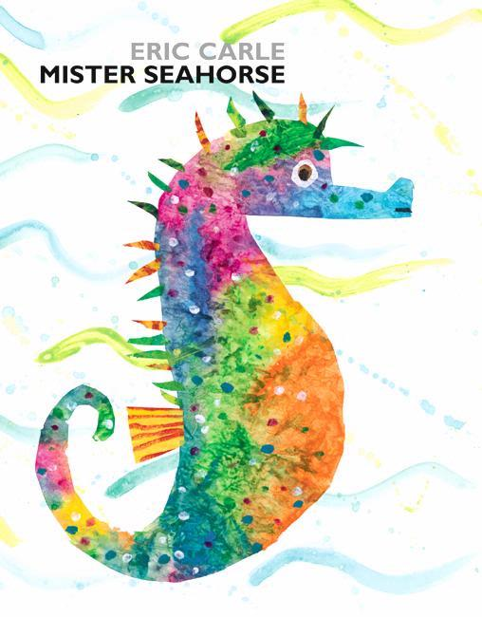
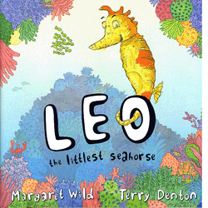
Each infant emerges head first and is a swimming, independent miniature of the adult. This birthing process usually takes a few hours. At times dad may use quite forceful muscular contractions to eject the last of his brood. It is an incredible sight when the young pour forth, and the process of giving birth is exhausting for father seahorses. As soon as the male is done birthing he is able to accept more eggs from his partner right away! For an excellent introduction to this topic, and to tie in the art project read Eric Carle’s Mister Seahorse, or Leo the Littlest Seahorse by Margaret Wild

“One morning Seahorse’s pouch is aching
“It’s time” thinks Seahorse, as his body starts shaking.
Then a hole in Seahorse’s pouch appears.
“They’re coming!” he thinks as he cheers,
For into the world the baby seahorses are waking!
One by one a hundred babies emerge,
Swimming out with a natural urge!
Baby seahorses are ever so tiny
Unlike human babies, they’re not very whiny
Even when they float away with the surge!”

Juveniles
The newborns are called juveniles and are tiny replicas of their parents. They may be as small as your smallest fingernail! Depending on the species, there may be as few as 12 juveniles or as many as 200. Once born, the juveniles are completely on their own and either drift away with currents or sink to the ocean floor. Often juveniles hold onto each other or their fathers for safety. Food is a top priority. Like adults, juveniles can eat thousands of tiny organisms each day. Those that find enough food and an object to cling to and escape predators will become adults. They’ll find mates and the cycle will continue!
“Now the juveniles have to live on their own
And find their own homes where they'll roam.
While they’re ever so small,
They still give it their all.
It takes hard work to survive all alone!
To get bigger the juveniles need to eat
And are always looking out for some treats.
As they eat they grow strong,
Find a home, and before long
They make babies, and the life cycle repeats!”

Protecting seahorses
Currently seahorses are facing many challenges. Population data for most of the world’s 35 seahorse species is not easily available. However, destruction worldwide of their coastal habitat making less areas where they could live, pollution (poisoning of the water with wastes, chemicals, etc), and over harvesting (taking more than can be replaced), mainly for use in Asian traditional medicine, have made seahorses vulnerable to extinction (death and complete disappearance of the species). The Chinese have used seahorses to make medicines for over 500 years. They believe this medicine can cure asthma, throat infections, exhaustion, and many other diseases.
Apparently, they use as many as 20 million sea horses a year. Seahorse trade is legal and unregulated (there are no rules about what can and can’t be done), and if this practice continues at this rate, we could push this amazing creature into extinction. To this end, conservation projects have been set up in recent years to establish sanctuaries and fish farms in order to ensure the continued existence of these mysterious and fragile creatures of the sea.
Also, sometimes seahorse habitats are destroyed because of coastal development and runoff pollution from humans. Unfortunately, 33 species of seahorses are considered threatened by the International Union for Conservation of Nature (IUCN). People can make a difference by refusing to buy seahorse souvenirs (gifts), supporting marine protected areas and educating others about these issues.
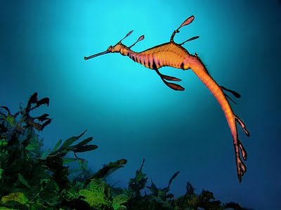
Sea Dragons
Image Credit: World’s Most Amazing Things. http://www.worldmostamazingthings.com/2011/04/sea-dragon-leafy-weedy-sea-dragons.html. Accessed 9/26/11. All Rights Reserved.
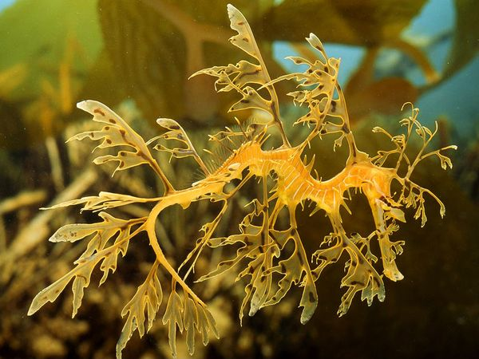
Many people wonder: What’s the difference between a sea dragon and a seahorse? Sea dragons, seahorses and pike fish are in the same family, the differences are that they are in different genera (genus: a grouping of organisms having common characteristics distinct from those of other such groupings.)Also, sea dragons are from Southern and Western coasts of Australia, while a lot of seahorses are from the tropical Indonesia and the Philippines areas. Their body shapes evolved to adjust to the different climates. So, weedy sea dragons are a type of fish related to seahorses and pipefish. Two species exist. The weedy sea dragon (Phyllopteryx taeniolatus) lives among weed beds in the seas off the southern coast of mainland Australia and Tasmania. The leafy sea dragon (Phycodurus eques) lives further along the southern and western Australian coast. Leafies grow to a length of about 14 inches (35 centimeters), while the slightly larger weedies can grow up to 18 inches (46 centimeters) long.
Image Credit: National Geographic. http://animals.nationalgeographic.com/animals/fish/sea-dragon/. All Rights Reserved. Accessed 9/26/11.
If it weren't for a very small, almost transparent, rapidly beating fin along the neck, a diver might never spy a weedy sea dragon among the kelp, weeds and other shallow ocean plants that it calls home. The dragons also feature a long sinuous (supple) fin along the back. Together, they allow the tiny animals to navigate currents that would otherwise push them away. Larger appendages (something that sticks out of an animal) that resemble fins or leaves are only cosmetic (for appearances) they don’t actually use them for anything but contributing to their concealment (to hide).
The common sea dragon, lives in the shallow waters off southern, eastern and western Australia. Its close relation, the leafy sea dragon (Phycodurus eques), is even better at camouflaging itself.
Generally slender, sea dragons have very long, thin snouts; slender trunks covered in bony rings; and thin tails which, unlike their seahorse cousins, cannot be used for gripping. Leafies are generally brown to yellow in body color with spectacular olive green-tinted appendages. Weedies have less flashy projections and are usually reddish in color with yellow spots. Weedy sea dragons may grow up to 18 inches (46 centimeters) in length. Although they have evolved to be highly camouflaged and have small defensive spines, it's not known what animals prey upon weedy sea dragons. They, however, eat small crabs, shrimp, etc.
Dance of the Dragons
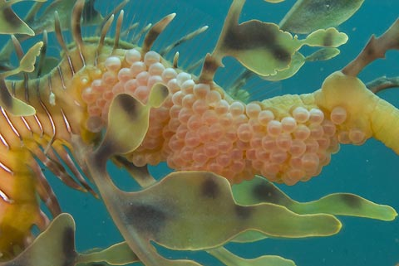
In addition to their unusual appearance, weedy sea dragons possess a unique mating ritual. They practice an elaborate courtship ceremony in which they actually appear to dance. One weedy sea dragon will mirror the other's movements exactly, creating an elegant series of slow back-and-forth gestures through the water.
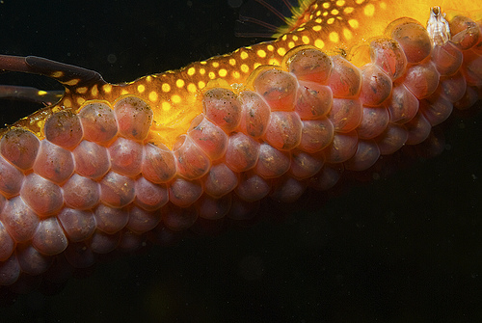
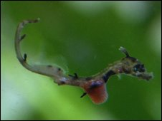
The dance may go on for hours. By the time it's finished, the female sea dragon will have transferred her eggs to the male, where they are fertilized. The male will then carry dozens of eggs to term. As with sea horses, sea dragon males are responsible for childbearing (interesting fact, the tail of a male leafy sea dragon will turn bright yellow when he is ready to mate). But unlike sea horses, male sea dragons don’t carry their eggs in their stomachs, instead of a pouch, like sea horses have, male sea dragons have a spongy brood patch on the underside of the tail where the eggs are embedded (stuck in), looking something like a cluster of pink pomegranate seeds, and their tails supply oxygen to the eggs through the father’s own blood vessels. Within two months, the eggs hatch, producing baby sea dragons bearing small, red yolk sacs still attached to their chests that feed them until they can find food on their own.
Young sea dragons seek shelter in the weed beds that give these creatures their name. Soon enough they're counted upon to take care of themselves and continue the dragon dance.
For amazing footage of the dragons dancing and embedded eggs, and hatching sea dragons, watch to the BBC natural history series Life, 4 minute sea dragon clip during the Episode 4: Fish segment or find the video clip online at http://www.youtube.com/watch?v=9MKkr_1Kqcw.

Legends of the Hippocamps
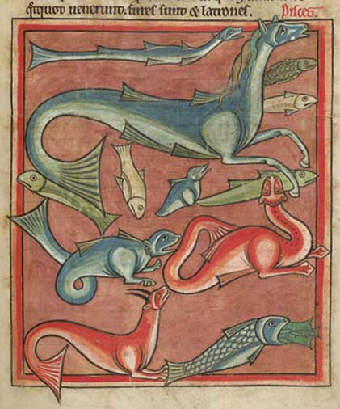
The hippocampus, or classical sea horse, is just one well-known example of a long list of sea creatures, following an old belief that the sea holds its own equivalents of every animal on land. So whatever animal you saw on land, they believed there was a version of that thing in the ocean.
Image Credit: © Ana Stoykova 1994, 2009-2011. © London, British Library, Harley MS 4751, ca. 1230-1240, f. 68rhttp://physiologus.proab.info/?re=510&mo=en All Rights Reserved.
The seahorse gets its name from the Greek words for the horse (hippos) and sea monster (kampos). Ancient Greeks believed that Hippokampoi (or Hippocamps) were the horses of the sea, the adult-form of the fish we call the "sea-horse" and that the tiny seahorse grew larger and larger until they became, Hippokampoi.
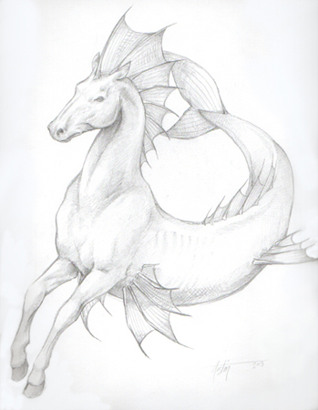
The ancient Greeks told a story that the violent and moody god of the sea, Poseidon, had a crush on Demeter, the goddess of grain and the harvest. Poseidon wanted to find some way to impress Demeter, but nothing he did impressed her or made her want to spend time with him. Finally, Demeter offered Poseidon a challenge, a chance to finally impress her, and win her heart or give up on her forever. She challenged Poseidon, the god of the sea, to create the most beautiful land animal ever seen. She thought he could never do it, but Poseidon worked on his creation for many days, first he came up with the giraffe, then the zebra, then the hippopotamus, and finally the camel. None of them impressed Demeter, she did not find them beautiful, so Poseidon kept working, and ﬁnally after many days, he created the horse. Demeter was amazed by its beauty when she saw it, and Poseidon was so happy with her reaction, he created a whole herd of horses for her.
Image Credit: Laurel D. Austin http://www.elfwood.com/~deva/Hippocampus.2678671.html. Accessed 9/21/11. All Rights Reserved.
For himself he created a herd of green horses with golden manes and the tails of dolphins to ﬁll his stables under the ocean. With his new horses to draw his chariot Poseidon would often travel on the surface of the sea.

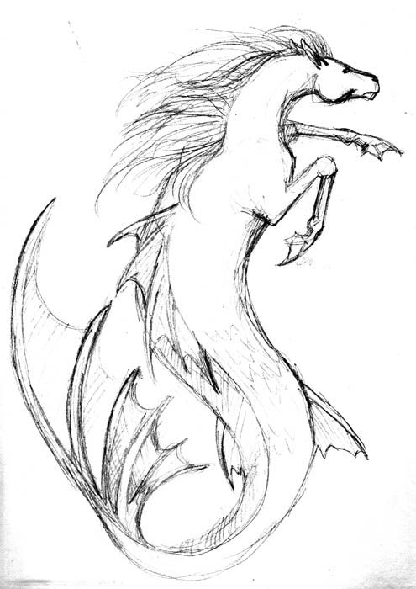
A different ancient legend tells of how horses came to be, and this one says that seahorses, or hippocampi came first. Long ago a herd of hippocampi wandered into the sea gods gardens and ate and destroyed their most beautiful and rare plants. The sea gods were angry with the hippocami and thought and thought about how they could punish the hippocampi for what they had done, thinking of one punishment, and then another, but nothing seemed right. Finally, they came up with an idea. The sea gods cursed the hippocampi to forever walk on four legs on the lands beyond the ocean, never again able to enter the sea and swim into their gardens. The children of the cursed hippocampi still roam today, as horses.
Image Credit: http://www.elfwood.com/~stevensone/Retro-Hippocampus-Sketch-.3255655.html. Accessed 9/21/11. All Rights Reserved.
People used to wait at the edge of the sea, believing that hippocampi had both lungs and gills, and were capable of breathing air and water. It was believed that during high tide they would sometimes come quite close to land, occasionally basking at the edge of the surf. They waited, hoping to catch a glimpse because it was said that wearing a necklace or bracelet braided from hippocampus hair would turn even the clumsiest person into an expert rider, and tack (equipment used to ride horses, like a bridle) made with hippocampus hair rope would tame the wildest, most stubborn horses.
If an equivalent of every creature that lives on land exists in the sea, according to acient beliefs, in fact many believed that the animals originated as sea animals and changed into their current form when they came to land, what animal would students like to see the sea version of?
Work as a group, have students work in small groups or as pairs, and/or have students individually develop their own seabeast legends and myths* based on an animal they love or have them keep their focus on the horse or dragon. How did horses come to be? Did dragons sink into the sea and hide, becoming tiny versions of themselves?
Note: The art project included could be modified into an illustration project for their story.
*A myth is a made-up story that explains the existence of a natural phenomenon — such as where an animal comes from (ex: a white bear born from a black one, or the existance of horses) in a creative way. Before humans found scientific explanations for things, they tried to understand them by telling stories. Myths—which often include gods and goddesses and other supernatural characters that have the power to make amazing and extraordinary things happen—are popular even when we know the real reasons things happen.
Myth Writing Steps from Jane Yolen:
http://teacher.scholastic.com/writewit/mff/myths_write_myth.htm Accessed 9/26/11. All Rights Reserved.
The biggest key is take a deep breath and just start. Don't worry whether something is good. Just let it flow onto the page. At this stage spelling, grammar, and run-on sentences really don't count, it’s the ideas that matter most.
1. Pick out the natural phenomenon/animal/thing you want to write about.
Make it something that really interests you. If you live in the desert, you might want to think about the way a single rainstorm can cause a flood. If you live in the North, think about the way a snowstorm can cover the ground like an icy blanket. If you live near the ocean, consider the way the tide comes in and out each day. In other words, find something that is familiar that you can observe.
2. Observe carefully.
It helps to know a thing well before trying to make up a story about it. The old myths were created by poets and storytellers who really knew the animals and nature around them. Find out as much as you can about the subject that you've chosen. It’s always a good idea to go to the library and find out what it is scientifically — and read what other storytellers have said about it.
3. Write down what is actual/real about the phenomenon.
Keep a record of what you have observed or read. What are the smells, sights, and sounds connected to this natural phenomenon/animal/thing? Where does it live? What does it do? Eat? Etc. You might want to try drawing sketches or painting pictures. Think of yourself as a reporter, not a storyteller.
4. Write down key words from your research.
If you're researching the desert, the words you find could be: sand, rain,gully, wash. Then look in a thesaurus or dictionary to find as many synonyms, phrases, and meanings for your words as you can. For example, under "sand" you might find grain, granule, gravel, shingle, powder, pulverizer. As you are writing those words down, think about the images behind them. It's those images that will help you build your myth. For example, I thought of a pepper grinder when I reached the word pulverizer. Once you've got a picture in your mind, it's time for the big WHAT IF. . . ?
5. Now! Ask yourself, WHAT IF?
Hop onto your image and head off into myth land. This is the point from which you need to start brainstorming! Be as creative as you can — let your imagination run wild! Take a picture in your mind of what an aspect of the world would be like if certain events happened. Then use this "what if" to create a story that explains why the natural phenomenon exists. The story can be as wild and crazy and fantastic as you want.
For example, take the pepper grinder from Step 4. What if there was a chef/cook to the gods who lived in a beautiful green countryside but became upset one day because no one ever complimented his cooking or said they liked it? While wandering around, he sat under one of those beautiful green trees and wished (always be careful what you wish for in a myth) that he could somehow make the gods take notice. And suddenly in front of him was a special pepper grinder that said, "Use me, and you will be noticed." And so the chef took the pepper grinder and used it that evening as he was seasoning the gods' stew. But instead of churning out pepper, it ground out sand — more sand than the chef had ever seen! The sand kept pouring out, completely covering the beautiful green countryside. And thus the desert came into existence.

Here Be Dragons!
Project idea, instructions, and images from Deep Space Sparkle Lesson Plans/ “Eric Carle” Inspired Seahorse www.deepspacesparkle.blogspot.com © Deep Space Sparkle/Patty Palmer 2009. All Rights Reserved
Tip: Before completing this project, read the book Mr. Seahorse by Eric Carle to help inspire your students’ imaginations.
Materials:
- Stack of White 12” x 18” Construction Paper
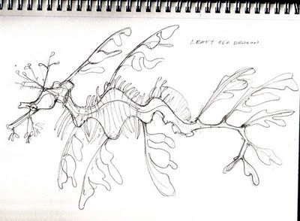
- (2-3 sheets per student for “Eric Carle” painted paper)*
Sea Dragon Image Credit: Sherri Y of Brush and Baren. http://brushandbaren.blogspot.com/2009/12/are-these-sea-lions-on-wharf-at-santa.html. Accessed 9/8/11. All Rights Reserved.
- Tempera Paints (see tips below)
- 1 sheet of 12” x 18” white paper per student
- Watercolors (either liquid or cake)
- Brushes and water
- Glue sticks
- Scissors
- Pencils
- Glitter and/or sequins
- White School Glue
*Tip: If you don’t have the time, resources, or room to have students make their own Eric Carle paper interestingly printed scrapbook paper or origami type papers can be substituted to make the seahorse (or seadragon) bodies.

Tip: Mix your own colors!
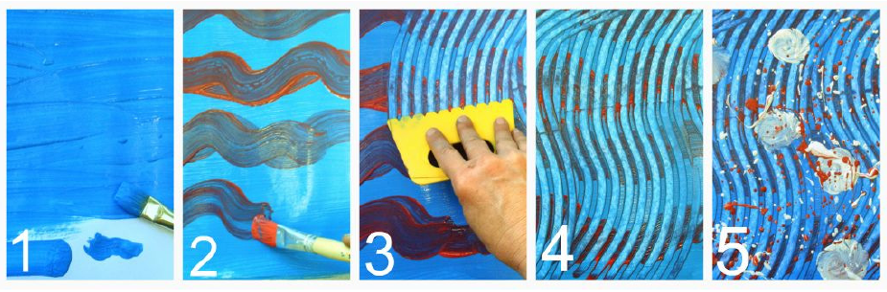
Squeeze a dab of red, yellow and white paint together to create a beautiful tangerine. Add blue and green to make teal, add white to red to make pink. You get the idea! The more interesting the colors, the better the project.
Put three containers of paint at each table/area for the children to share. Make sure the other tables have different colors of paint. Once the child has complete one painting, he can rotate to the next table, to experience a different set of colors.

Step 1: Painting “Eric Carle” Style Seahorse Paper
Nothing will bring bigger smiles to your students this year more than saying these two words: Splatter Painting! Of course, we’ll be doing more than that, but it’s nice to get them excited. Make sure that each group has a tray that includes many nifty texture producing items you can come up with like rollers, brayers, scrapers, plastic forks, etc. Use what you have round, or scour art and crafts, play dough tool sets, or paint departments for inexpensive and interesting scrapers.
1. Have students choose one color from the three tubs of paint and paint the entire paper with that one color. Have them use large brushes or else the children will be painting all day.
2. Next, chose a contrasting color and paint stripes, polka dots or zig-zags over the wet paint.
3. Then, using one of the texture tools, scrape the paint and watch the colors swirl together.
4. Wait for the ooh’s and ahh’s then splatter paint or continue adding textures.
5. Of course, splattering is not necessary, so demonstrate other options: dots, swirls, more scraping, etc.
Tip: This is a fun stage of this project, so when it’s time for the children to have a go at their painting, watch them. It’s quite inspiring, not to mention utterly adorable!
Step 2: Painting the Ocean Background for the Seahorse
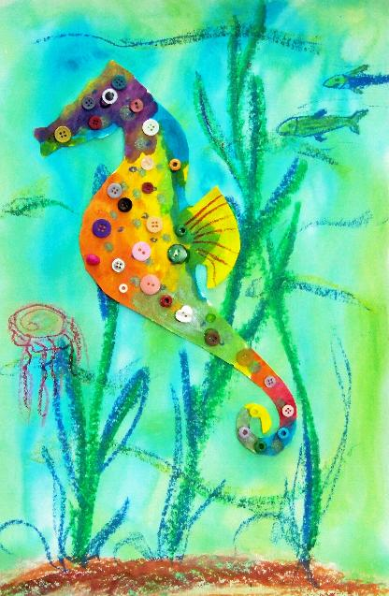
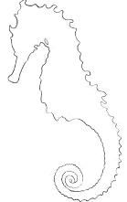
This step is the easiest of all the steps and takes very little time to do. The idea is to have the children paint lines to imitate water. Using a small watercolor brush, have the students paint swirls and wavy lines of blues, green and purple watercolor paint to the white construction paper. That’s it. Now you have an ocean!
Image Credit: http://www.libraryarts.com/seasonal.html. Accessed 9/8/11. All Rights Reserved.
Step 3: Seahorse Template
Either drawing their own or using one of the templates provided, have students trace a seahorse onto the back of an “Eric-Carle” painted paper. Cut out the seahorse and glue to the “ocean.”
Step 4: Embellishing the Artwork
Now it’s time for students to give their seahorse a personality.
1. Add eyes (plastic wiggly eyes are fun if you have them), buttons for spots, a mane, stripes, etc. using the scraps of extra “Eric-Carle” paper. They may want to stretch it out a little, add extra fins, and create a leafy sea dragon!
2. After decorating the seahorse, create his habitat by adding seaweed, schools of fish, shells, starfish, etc. Don’t be disappointed if some kids bow out at this point. It’s been a long lesson, and for them, their seahorse is perfectly fine without an eye.
3. This is a good time, however, to bring out the glitter shaker and ask if they are completely sure they’re done. If they suddenly perk up, hand them a bottle of white school glue and ask them to “draw” where they would like the glitter to go. Suggestions include hair, dots, eyes for fish, etc.
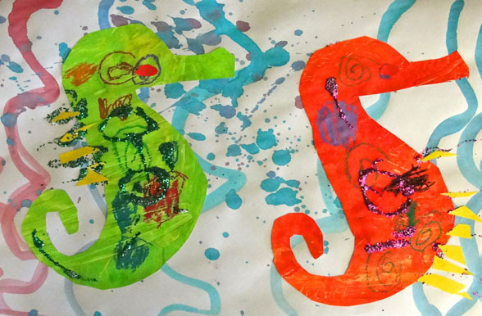
Tip: Always shake the glitter for the children. Encourage them to point and direct, but to avoid a supreme mess, keep the glitter shaker tight in hand! If you can, it’s always best to do glitter over a box or outdoors.

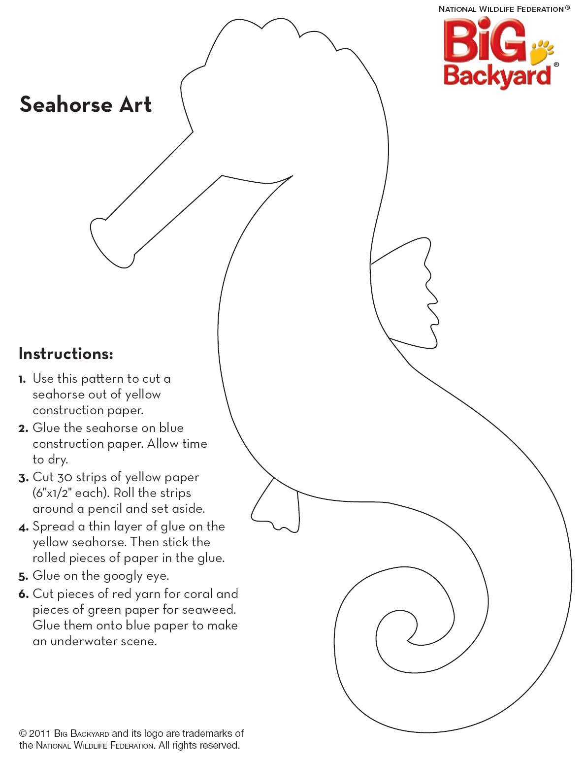
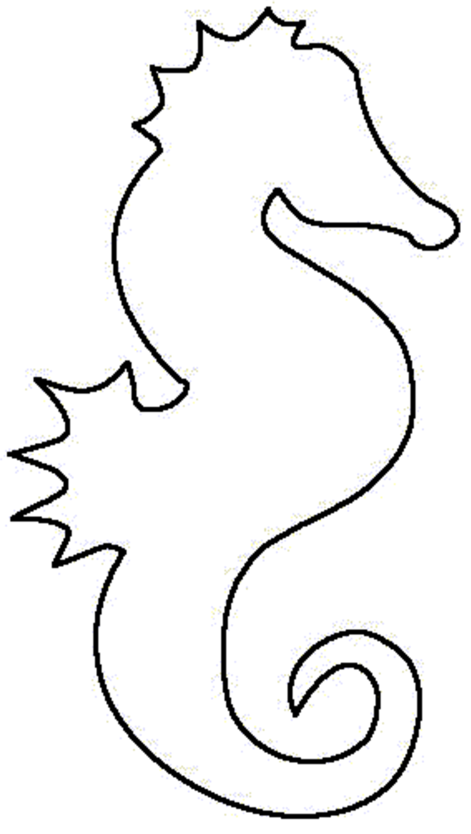
Quick Idea: How to Draw a Seahorse
http://www.drawspace.com/lessons/f12/seahorse
Talk about fun to draw! Always moving, always changing! Have students stop and focus on one thing at a time: shape of head, undulating shape of body, locations of appendages, shape of appendages. First lightly sketch proportions, then outline the various contours, and finally add hatching lines.
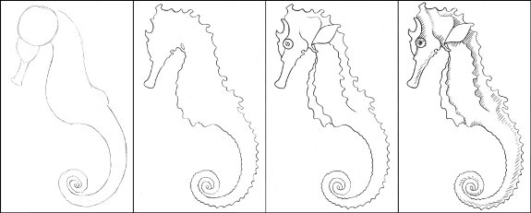
Sea Dragon Image Credit: Sherri Y of Brush and Baren. http://brushandbaren.blogspot.com/2009/12/are-these-sea-lions-on-wharf-at-santa.html. Accessed 9/8/11. All Rights Reserved.

Can students add details and create their own leafy sea dragon?

